|  |  |
| --- | --- |
| No. of Pages | **6** |
| No. of Questions | 8 |

**Department of Computer Science and Engineering**

**FINAL EXAMINATION SUMMER 2014**

**CSE421: Computer Networks**

**Total Marks: 90 Time Allowed: 3 Hours**

* Answer **Any** **Six (6)** questions out of **Eight (8)** questions.
* Figure in bracket [] next to each question indicates marks for that question.

## Question No. 1

1. Draw the transactions when a client needs to request to a webserver for two objects. Draw starting from the three-way handshake. The HTTP1.1 is persistent without pipelining. [6 marks]
2. What makes the HTTP protocol state full? What is needed on the client side and server to maintain the state full state? [5 marks]

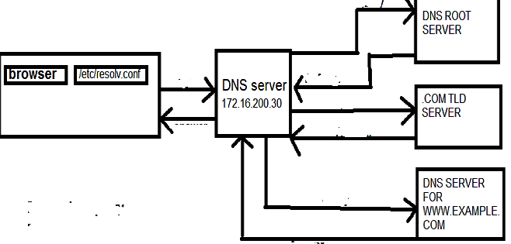

**Figure No. 1**

1. What kind of DNS query is shown above the above figure no. 1? Complete the diagram by putting the sequence number for the arrows according to the sequence of operation. [4 marks]

## Question No. 2

1. Suppose a company is given a block **200.20.20.64/26.** [8 marks]

The company needs to distribute these addresses to three branches as follows:

1. The first branch needs 30 addresses
2. The second branch needs 12 addresses
3. The third branch needs 12 addresses

Create subnets as per requirements and show calculations.

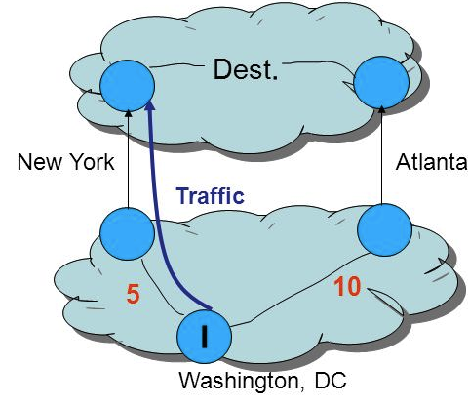

**Figure No. 2**

1. I Router chooses New York to go the destination instead of Atlanta, shown in figure no. 2 will be the correct decision? [4 marks]
2. How does AS_PATH attribute help in preventing loops? [3 marks]

## Question No. 3



**Figure No. 3**

1. The above figure no. 3 shows multiple unequal cost paths to a destination 192.168.90.0 network. In which table would you find the above paths? Does it have a successor and a feasible successor route, explain how? What does the letter “P” implies? [6 marks]
2. The successor to a route goes down; state all probable actions that a router will take next.

[4 marks]

1. If a neighbour does not appear in the neighbour table, what should you check first for troubleshooting? [3 marks]
2. What would happen to a packet caught in a routing loop if all the distance vector mechanisms for avoiding such loops failed? [2 marks]

## Question No. 4

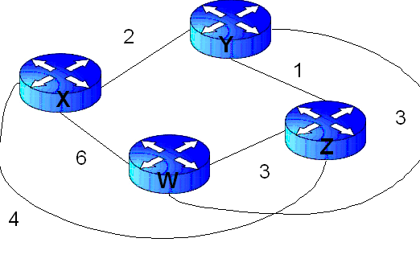

**Figure No. 4**

1. Link state routing protocol uses Dijkstra’s algorithm. Now using Dijkstra’s algorithm, compute the shortest path from Xto all other remote networks shown in Figure no.4. Use the table provided. [4 marks]
2. OSPF routing protocol does not use holdown timers for loop prevention, why? [2 marks]
3. What does a link state packet contain? What does each router do when link state packets have all been exchanged? [4 marks]
4. Refer to figure no. 5 below, why do the routers A,B,C,D and E have different router IDs? Why were the interface IP addresses not used in determining the Router ID? [5 marks]

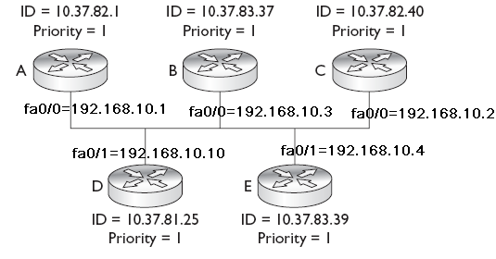

**Figure no. 5**

## Question No. 5

1. A client using TCP opens a connection with a server using an initial sequence number of 301. The server opens the connection with an initial sequence number of 1001. Show the three TCP segments during the connection establishment. Be sure to show which control bit flags are set. Also the client sends 1 data packet of 500 bytes to the server and the server also sends 3 data packets of 300 bytes. Then the client only acknowledges. Draw the whole transaction showing sequence no., ack no. and the codes/flags. [5 marks]
2. What is Closed Loop Congestion Control? Name some Closed Loop Methods and explain one briefly. [5 marks]

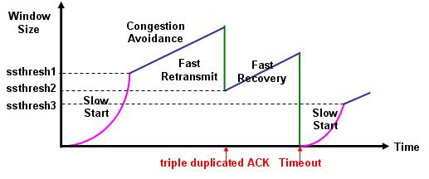

**Figure No. 6**

1. Refer to the diagram above in figure no. 6, there are three ssthresh holds shown. How are they calculated? [5 marks]

###### Question No. 6

1. Suppose that the data bytes of an original datagram of 3360 bytes which includes 20 bytes of header. The datagram is to be sent from PC1 to PC2. The datagram has to go through the network R1 –R2. The network between R1 and R2 only allows maximum data frames of 700 bytes. The identification number of the first datagram is 333. And header length is 20 bytes. So fragment the data accordingly using the following table structure. [5 marks]
2. what if for the above scenario the don’t fragment bit was on? [2 marks]

|  |  |  |  |  |
| --- | --- | --- | --- | --- |
| Identification  No. | Total length  field | Fragmentation  offset | M: more fragment bit | Range of data bytes in the frame |

[4 marks]

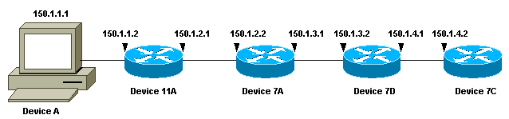

**Figure No. 7**

1. In the above figure no.7, if Device A issues a traceroute to the IP address 150.1.4.2. How does it to stop increasing the TTL value after it receives a reply from Device 7C? [4 marks]
2. In the figure no. 8 below what kind of attack is this and how is the attacker able to target the victim? [4 marks]

###### 

**Figure No. 8**

###### Question No. 7

1. What are the disadvantages of using “Polling” MAC protocol? [3 marks]
2. A switch maintains a table to forward frames as shown below in figure no. 9. This switch remains inactive for 65 minutes. Then a ping is sent from 0040.0b78.3dcd MAC to 00do.bab1.b36a MAC. What will the switch do and why? [4 marks]

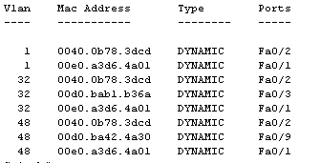

**Figure No. 9**

1. How is the CRC bits calculated on the sender side to be sent with the data? [4 marks]

**Z:\>arp –a**

**Interface: 10.253.15.72 ---0x4**

**Internet Address Physical Address Type**

**10.253.1.2 00-12-3f-ed-3f-2c dynamic**

**10.253.1.6 00-13-72-51-d5-a9 dynamic**

**10.253.1.13 00-11-4f-67-3f-c8 dynamic**

**Figure No. 10**

1. What does the output in the above figure no. 10 represent? How does it help in our ARP process? [4 marks]

###### 

###### Question No. 8

1. IPv6 header has been simplified when compared to IPv4 header. But IPv4 header size is smaller than IPv6 header. So how is the simplification achieved? [4 marks]

**1a43::f301:22::fa**

**Figure No. 11**

1. Expand the following IPv6 address to it original form. Is it a valid address? [4 marks]
2. In dynamic stateless auto configuration the following what is added in the middle of the MAC to make it 64bytes? What else is done to the address? [3 marks]

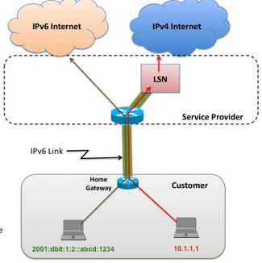

**Figure No. 12**

1. In the above figure no. 12, what efficient way can we maintain communications between IPv6 to IPv6 hosts and IPv4 to IPv4 hosts? [4 marks]

##### THE END